Newly Identified Stem Cells Breathe Life into Lung Disease Therapy
FEBRUARY 4, 2015 / TODD DUBNICOFF
Breathing. So crucial to life yet so easy to take for granted—maybe because it’s one of the few functions our bodies control both unconsciously and consciously.
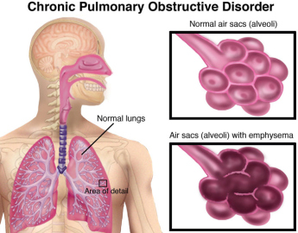
credit: Move Forward
But I imagine people with lung disease, such as chronic obstructive pulmonary disease (COPD) are all too aware as their continual struggle to breathe worsens over time. COPD, the third leading cause of death in both the U.S. and the world, is caused by progressive damage to the lung’s air sacs, or alveoli, which deliver the oxygen in our lungs to the blood and onto our organs. Besides a lung transplant, which is a very impractical option, there aren’t any cures a doctor can offer. Still, patients and physicians should be encouraged by the identification of a rare lung stem cell population reported on January 29th in Nature, which may point to much-needed new therapeutic approaches.
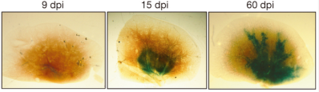
Mouse lung after flu virus-induced lung damage. In response to infection, p63+Krt5+ lung stem cells (stained blue) begin to expand and migrate to sites of injury. Credit: Nature
Previous clinical studies have observed that survivors of the sudden, widespread lung damage from acute respiratory distress syndrome (ARDS)—one of the symptoms of the H1N1 swine flu pandemic—can fully recover lung function in just six months. In this current report, collaborative research teams from Singapore and New England showed in animal studies that a lung stem cell population, dubbed p63⁺Krt5⁺, was essential for regeneration after lung damage caused by H1N1 infection. Using a sophisticated genetic technique, the team tracked these p63⁺Krt5⁺ cells following infection-induced lung damage. In 15 days after infection, and even more so by day 60, the stem cells clearly had expanded, migrated into the damaged regions of the lungs, and begun assembling into new alveoli. In non-infected animals these results weren’t observed.
To make sure these results were specifically due to the p63⁺Krt5⁺ cells, the researchers reached into their genetic toolbox again to enable them to kill off just the p63⁺Krt5⁺ cells during this experiment. Now, when the infection-induced lung damage was repeated no lung regeneration was seen, resulting in lung scarring and poor oxygen capacity in the animals. Their follow up experiment was the most intriguing: again, the p63⁺Krt5⁺ stem cell kill off and infection-induced lung damage was repeated but this time p63⁺Krt5⁺ stem cells grown in the lab were transplanted to the lungs. Following transplant, lung regeneration was restored and the stem cells matured into alveolar cells, which are components of the lung air sacs.
The existence of these lung stem cells and their role in lung regeneration is bolstered by an independent UCSF study, reporting in the same issue of Nature, that show the cells’ ability to migrate to the site of injury and contribute to healing. They include fascinating video microscopy of the stem cells’ migration into the lung tissue.
All of these results suggest a new avenue to explore for treating deadly lung diseases like COPD, which killed an estimated 3 million people worldwide in 2012. Patricia Inacio, writing for Lung Disease News, summed it up this way:
“Enhancing this ability of the lungs to regenerate after an injury can aid in the treatment of a wide range of pulmonary diseases. This study opens up new therapeutic possibilities, especially with the stem cell-based therapies for a variety of diseases.”

